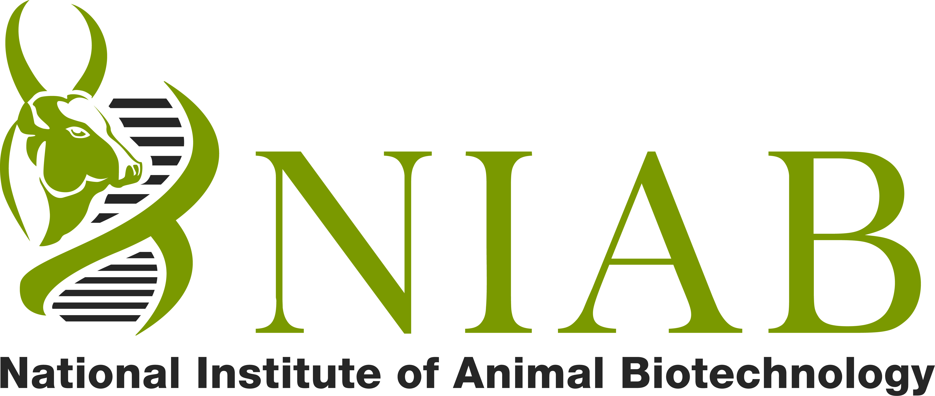
राष्ट्रीय पशु जैव प्रोधोगिकी संस्थान
National Institute of Animal Biotechnology
(An Autonomous Institute of the Department of Biotechnology, Ministry of Science & Technology, Govt. of India)
Aryabhata Block, C. R. Rao AIMSCS, University of Hyderabad Campus, Central University Post Office,
Prof. C. R. Rao Road, Hyderabad, Andhra Pradesh, India - 500 046
Email: spm@niab.org.in Telephone: +91 40 2301 3903 Telefax: +91 40 2301 0745

NOTICE INVITING TENDERS
RATE CONTRACT/CONS/ 13-14

Sealed Tenders are invited on behalf of Director NIAB , from reputed manufacturers / authorized distributors of Indian / Foreign Firms for entering in to Annual Rate Contract for supply of Laboratory Research Chemicals/ Glassware / Plastic ware / Consumables on Catalogue /Price List basis with discount offered for the following Manufacturer’s products.

I Chemicals / Media / Kits / Consumables
- Qualigence Fine Chemicals / Himedia Laboratories Pvt. Ltd.
- Bangalore Genei Pvt. Ltd / Fisher Chemicals / TakaRa / Clotech / Machenary - Nagel
- Loba Chemicals Pvt. Ltd. / Merck Ltd ( Indian and Imported ) ,Nalgene
- Sigma Aldrich Chemicals Pvt. Ltd/ Invitrogen Bioservices India Pvt. Ltd.
- Qiagen /Santa Cruz Biotechnogy/Cell Signaling Technologies G E Healthcare Ltd /New England Biological/ Finnzymes/Miltenyi Biotech , BD BBL & DIFCO/ Sisco Research / Promega / Roche / Cole –Parmer / Genex
- Fermentas/Ambion Inc / Hyclone /Strategene / HP Sales Cartridges / If any other reputed Brands

II Glassware :
- Borosil Glass Works Ltd. ,Duran / Riviera Glass Pvt. Ltd ,Vensil Glass Works Ltd.
- Qualigence Glassware / Blue Star ,If any other reputed Brands

III Plasticware:
- Axygen Scientific Pvt. Ltd. / Tarson Products Pvt. Ltd.,Laxbro Mfg. Co./
- Corning / BD Falcon / Brand GMbH , If any reputed other Brands

IV FILTERATION PRODUCTS / Membrane/Filters:
- Millipore India Pvt. Ltd.
- Pall Life sciences / Whatman Asia Pacific , If any other reputed Brands

PRODUCT CATEGORY LIST

S.No. | PRODUCT CATEGORY | COST OF THIS DOUMENT.  (RS.) | EMD (RS.) | PBG (RS.)
1 | CHEMICALS  Genl. Lab. Chemicals, Fine Chemicals, Solvents, Bio-chemicals, Reagents, Foreign Chemicals (Custom Bonded Ware House/Indian Prices Imported) etc. | 500  Non refundable | 5000 | 20,000  Not to be submitted at this stage  -----------  To be submitted if Rate Contract is awarded to the firm.
2 | GLASSWARE  Laboratory Glassware (both pre-fabricated and custom made) | 500  Non refundable | 5000
3 | PLASTICWARE  All type of Laboratory Plasticware | 500  Non refundable | 5000
4 | FILTERATION PRODUCTS  Filter paper,  Filter Membrane etc. | 500  Non refundable | 5000
5 | MISC. LABWARES  TLC Plates, Surgical gloves, Tweezers,Cotton Rolls, Aluminium Foils,Disposable Syringe, PVC Tapes, Adhesive Tapes,Tissue paper Rolls, dish Washing Powder, Detergent Powder, Lab Coats, Face Musk etc. | 500  Non refundable | 5000

ARC FORM

APPLICATON FORM FOR ANNUAL RATE CONTRACT WITH NIAB, HYDERABAD

1 | NAME OF THE FIRM
2 | CORRESPONDENCE ADDRESS  (With Telephone/Mobile/Fax No./E-mail address and also with official website, if any)
3 | NAME OF THE REPRESENTATIVE  (With Tel. / Mobile No.)
4 | Are you having RC with any other DBT /CSIR /Govt. Deptt./Res. Instt for the year 2012-13 If yes, pls. mention the details
5 | CATEGORY OF MATERIALS  (Please See Details In The R.C. Document)  Chemical/Glassware/Plasticwares/Misc. Labwares etc.
6 | NAME OF AUTHORISED DISTRIBUTOR/ SUPPLIER  (With Telephone/Mobile/Fax No./E-mail address and also with official website, if any)
7 | ANNUAL GROSS SALE DURING THE LAST THREE YEARS. (relevant to product category)
8 | RATE OF DISCOUNT OFFERED
9 | SALES TAX
10 | ANY OTHER CHARGES / TAXES  (Please Specify Clearly) Freight Charges, Delivery charges Packing Charges, Dry Ice Charges etc)
11 | DELIVERY SITE | “DOOR DELIVERY” at Stores, NIAB, Hyderabad Material may also be required to be delivered to the desk of the user scientist.
12 | TERMS OF PAYMENT | Within 30 days of the delivery of the material. Payment will be made against submission of pre-receipted Bill alongwith signed Challans. Bill will be raised only after full and final supply of materials. No part Bill will be raised against a single order.
13 | VALIDITY OF RATE CONTRACT | One year from the date of enlistment / will be decided by NIAB

PRICE SHEDULE FORMAT
Sl.No | Description | Make/Company /Manufacture | Discount | TAX / VAT
1 | Chemicals / Media / Kits / Consumables
2 | Glassware :
3 | Plasticware:
4 | Membrane/Filters
5 | MISC. LABWARES

- Please Offer uniform discount for the entire Catalogue prices.

- Chemicals having expiry of less than six months not to be supplied.

- No request for increase in prices will be entertained for one year from the date of entering into the rate contract.

- The prices should be inclusive of packing & forwarding. If ex-works / go down prices are quoted, then packing& forwarding documentation, freight and insurance charges must be specifically mentioned separately.

- Sale Tax / other Govt. levies will be paid at actual and prevailing rates of Excise duty and Sales tax etc. may be mentioned separately.

- No other charges other than those mentioned clearly in the quotation will be paid.

- The Bidders are requested to quote Customs Bounded Ware House Prices or High Seas Sale prices, if applicable. NIAB is custom duty exempted having DSIR Certification.

- Prices quoted should be up to NIAB , HYDERABAD .

- The current price list should be submitted.

- The item supplied should be certified by the supplier to be of genuine quality/make and procured from the authorized stockist /dealer/Manufacturer.

- The Supplies if rejected due to non conformity with the specifications has to be removed and replaced within the stipulated period free of cost at the ultimate destination. In case of failure to do so the rejected supply shall be disposed off by NIAB at their own discretion and no claim shall be entertained.

:: GENERAL TERMS AND CONDITIONS::

- (a) Cost of the Annual Rate Contract (ARC) Form is specified along with the Product Category. This form can either be purchased from our office or can be directly downloaded from our official website (http://www.niab.org.in). This Document Cost is NON –REFUNDABLE.

(b)Demand Draft should be drawn in favour of National Institute of Animal Biotechnology payable at Hyderabad should be enclosed along with your application, towards cost of the Annual Rate Contract (ARC) Form.

(c) . Each application should be accompanied by
  - R.C. Enlistment Form,
  - A Demand Draft towards the ARC Form (RS 500 )
  - A Demand Draft towards Earnest Money Deposit (RS 5000)
  - (NO PBG AT THIS STAGE)

- (a) In case of rejection, the EMD money will be returned to the applicant promptly. However ARC document fee is NON – REFUNDABLE.

(b) The EMD money will also be returned to the successful applicants, who will be enlisted, only after furnishing the Performance Bank Guarantee, as per specified schedule.

- The following documents are to be attached with the proposal :
  - Vendor Information Form,
  - Cost of Application form in the form of a DD (if downloaded from internet).
  - Demand Draft for EMD

- (i) Successful applicants will be intimated to submit their Pricelist/Catalogue/Brochure/ Pamphlet only after enlistment. Around 30-60 copies of these books will require to be circulated among the various departments, labs, divisions and scientists.

(iii) Prices of the products are also to be submitted in the form of CDs or Floppies.

- Incomplete proposal and delayed submission of proposal will be rejected. Proposal must be neat and clean and duly typed. HANDWRITTEN OFFER WILL BE REJECTED.
- Under a Product Category, the firm must fulfil all the mentioned requirements failing which its offer will be rejected as incomplete.

- Mere submission of application/proposal does not imply acceptance of the same at this end and the firms will be enlisted only after meeting the laid down qualifying parameters for which our decision will be final.

- Printed terms and conditions of the applicant on their Quotation Form/literature/letter etc. if any, will not be binding on us.

- Enlistment under Rate Contract with this institute does not ensure business of any minimum quantum, whatsoever.

- Enlistment can be cancelled at any time if the firm is found as “Habitual Defaulter” or supplying sub-standard material or for any other reason, based on the complaints received from the users\/s.

- The Director, NIAB reserves the right to reject any/all the proposal/s without assigning any reason whatsoever.

- Your offer should reach this office on or before 20/07/2013 in a sealed cover addressed to “THE DIRECTOR, NIAB, HYDERABAD superscribing ‘APPLICATION FOR ARC”.
- Any deviation from the Terms & Conditions mentioned above will imply disqualification for the firm.

- All Disputes subject to Hyderabad jurisdiction only

- Tenders in sealed covers should reach latest by 14.00 hrs on 20th July 2013.
IT WILL BE OPENED AT 14.30 ON 20/07/2013 IN THE PRESENCE OF THE BIDDERS OR THEIR REPRESENTATIVE WHO WISH TO BE PRESENT.

All queries /submission of tender/Address of correspondence

Manager (Stores & Purchase)
National Institute of Animal Biotechnology
Aryabhata Block,C.R.Rao ,AIMSCS ,University of Hyderabad Campus, ,
Hyderabad, Andhra Pradesh,India,PIN: 500 046
Email: spm@niab.org.in Telephone: +91 40 2301 3903

Manager
Stores & Purchase

CHECKLIST

S.No. | I/We have done the following | Yes/No/NA
1 | ARC Application is NEATLY TYPED , Cutting/Over-writing etc. is initialled and stamped
2 | DD towards the ARC Document Cost is enclosed (Rs 500)
3 | EMD DD as mentioned in the Product Category List is enclosed (Rs 5000)
4 | DD(s) is/are in favour of National Institute of Animal Biotechnology payable at Hyderabad.
5 | Read & Understood all the terms & conditions & we agree with them.
6 | Name /contact details written at the back side of all Demand Draft.

My Envelope must Contains: ARC Application Form + ARC Form Fee DD + EMD DD
Any other relevant /useful information about product list

IMPORTANT NOTES:

- We hereby declare that all the particulars given in this application are true, complete to the best of our knowledge and belief and we will produce all the relevant documents promptly, if necessary or as and when asked for by the NIAB. In the event of any information being found false or incorrect or ineligibility being detected even after the approval of Rate Contract, our contract may be cancelled and all our claims may be forfeited by the NIAB.

- We also declare that we will not sell our products at a lesser price to other parties than those given to you and in the event of happening of such situation, we will be bound to refund the difference and our enlistment may be cancelled at the discretion of the NIAB.

- We also undertake that all the terms such as Product Range, Price, discount, Delivery/other charges, Terms of Payment and also the name/s of the Distributor will remain unchanged during the period and no alteration will be done without your official approval. However, we will promptly change our Distributor/Supplier if a request/complaint is received from your end with regard to this effect due to any reason.

Date : Signature :

Place : Name :

Designation :

Seal of the firm :

-----------------------------------------------------------------------------------------------------------------------------------------
This Tender Document

Issued to: __________________________________

___________________________________

Date: Signature of the Issuing Officer,

NIAB

