**National Institute of Animal Biotechnology**

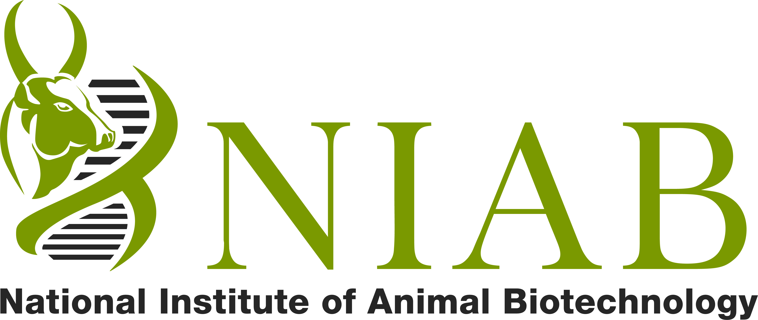

**(An Autonomous Institute under Department of Biotechnology)**

Survey No 37, Opp. Journalist Colony, Near Gowlidoddy, Gachibowli, Hyderabad - 500032

**APPLICATIONS / NOMINATIONS ARE INVITED FOR THE POST OF DIRECTOR, NATIONAL INSTITUTE OF ANIMAL BIOTECHNOLOGY (NIAB), HYDERABAD ON DEPUTATION (ISTC) / ABSORPTION**

The National Institute of Animal Biotechnology (NIAB), is an autonomous institute established by Department of Biotechnology, Ministry of Science & Technology, Govt. of India at Hyderabad. NIAB is aimed to harness novel and emerging biotechnologies and create knowledge in the cutting edge areas for improving animal health and productivity. The Institute’s research focus is on animal genetics and genomics, transgenic technology, reproductive technology, diseases, nutritional enrichment, and bioinformatics. The Institute aims at translational research leading to genetic enhancement of Indian Livestock species and basic research towards development of novel vaccines, diagnostics and improved therapeutic molecules for farm animals. The details about the Institute are available at **www.niab.org.in.**

Applications / Nominations are invited from Indian Nationals including non-resident Indians (NRIs) for the post of ‘Director’, National Institute of Animal Biotechnology (NIAB), Hyderabad. **The position offers a unique opportunity to those willing to take up a challenging assignment** and provide dynamic leadership in scientific, academic and administrative matters relating to the institute. The candidate is expected to establish NIAB as a world class research institute and guide multi-disciplinary research teams.

**1. Eligibility Criteria**

Scientists from Central/State Governments, research institutes, autonomous bodies, Government funded Research organizations / Institutes etc

(i) holding analogous post on regular basis in the parent cadre / Department or

(ii) with 5 years’ service in the post with Pay Matrix Level-14 (Rs. 1,44,200 – 2,18,200) or equivalent in the parent cadre / Department and possessing the qualifications & experience as below.

**2. Job Specifications**

1. To provide academic and administrative leadership to the institute.
2. The post carries a basic pay of Rs. 2,25,000/-(Level-17 as per 7th CPC) with allowances as per Central Government Rules for appointment on Deputation (ISTC)/Absorption.

1. The period of deputation includes period of deputation in other ex-cadre posts, held immediately preceding this appointment in the same or other organization / Department should ordinarily not exceed 5 years. The maximum age limit for appointment on deputation (ISTC) should not exceed 58 years as on the closing date of receipt of applications.

**3**. **Qualifications**

**Essential:**

1. A Ph.D. degree in Veterinary Sciences/ Animal Sciences/ Modern Biology/ Life Sciences/ Dairy Sciences or equivalent with specialization in the relevant area.
2. A minimum of 15 years of research experience in responsible positions in the area of Veterinary Sciences/ Animal Sciences or any discipline relevant to Animal /Veterinary Sciences.
3. Excellent track record in the form of quality publications, evidence of patents and Technologies developed/Transfer.
4. Professional eminence in the form of fellowships of national / international academics, national / international awards etc.

**Desirable:**

1. Proven ability to interact with national and international organizations.
2. Understanding of various overarching aspects of Animal Science / Veterinary Science or any discipline relevant for Animal/Veterinary Sciences.

**4. General:**

1. The applicants in Central/State Government organizations / Public Sector Undertakings / Autonomous Organizations must send their applications “Through Proper Channel”. The applications received without the recommendations of the employers will not be considered.
2. The date of determining the age limit shall be the closing date for receipt of applications.
3. The post will be for a five year tenure initially or on attaining the age of superannuation as per Government of India rules, whichever is earlier.

**5. How to apply / nominate**

5.1 Complete applications (7 copies) strictly in the format given at DBT and NIAB’s website: <http://dbtindia.nic.in> and NIAB website [www.niab.org.in](http://www.niab.org.in) with a passport size photograph fixed at the space shown in the format along with testimonials including list of publications indicating impact factors should be sent to Shri Subodh Kumar Ram, Under Secretary, Department of Biotechnology, Room No. 69, Block-2, CGO complex, Lodhi Road, **New Delhi-110003**, superscribing the cover “ Application for the Post of Director, National Institute of Animal Biotechnology (NIAB), Hyderabad” so as to reach within 30 days from the from the date of publication of this advertisement in the Employment News. The closing date for the candidates residing abroad, Andaman & Nicobar and Lakshadweep Islands, States/Union Territories in the North-Eastern region, Sikkim, Union Territory of Ladakh, Sub Lahaul and Spiti districts of Himachal Pradesh, Pangi sub-division of Chamba District of Himachal Pradesh will be 45 days. The soft copy of the application may also be sent by email to [aipsu.dbt@nic.in](mailto:aipsu.dbt@nic.in) and [subodh.ram.dbt@nic.in](mailto:subodh.ram.dbt@nic.in).

5.2 Nominations by distinguished experts may also be considered depending upon merit and the area of expertise. Eminent experts and distinguished scientists may also kindly nominate potential candidates for the position both by post and by email at the above mentioned address.

*******

**Note:**

**1. This advertisement will appear/ has appeared in the Employment News on 27th March 2021**

**2. Any further information about this advertisement will only be posted on the DBT or NIAB websites viz.** [**www.dbtindia.nic.in**](http://www.dbtindia.nic.in) **or** [**www.niab.org.in**](http://www.niab.org.in)

**99013/11/2021-AIPSU-DBT**

**________________________________________________________________**

**FORMAT OF APPLICATION**

**APPLICATION FOR THE POST OF DIRECTOR (ON DEPUTATION (ISTC), NIAB, HYDERABAD**

1. Name of the applicant (In Block Letters):-……………………………………………..

Affix Passport

Size Photograph

1. Mother’s Name :- ………………………………………………………………………………...
2. Father’s/Husband’s Name.…………………………………………………….……………..
3. Date of Birth (DD/MM/YY)………………………………………………….………………..
4. Postal address: ………………………………………………………………………………….…

………………………………………………………………………………………………………….…

PIN ……………………………………………………………………………….

E-Mail …………………………………………………………………………

Telephone …………………………………………………………………….

1. Permanent Address: ……………………………………………………………………………

……………………………………………………………………………………………………………

PIN …………………………………………………………………………………………………….

1. Nearest Railway Station / Airport: ..……………………………………………………
2. Nationality: …………………………………………………………………………………...…….
3. Marital Status: ………………………………………………………………………………………
4. Whether belongs to SC/ST/PH/OBC (if yes, please attach certificate): ……………………………
5. Educational Qualification (from matriculation onward):

|  |  |  |  |  |  |
| --- | --- | --- | --- | --- | --- |
| S. No. | Degree | Board/University | Division | Year of Passing | Subjects |
|  |  |  |  |  |  |
|  |  |  |  |  |  |
|  |  |  |  |  |  |

1. Experience (from current to oldest):

|  |  |  |  |  |  |
| --- | --- | --- | --- | --- | --- |
| S. No. | From | To | Name of Organization | Position held | Scale of pay |
|  |  |  |  |  |  |
|  |  |  |  |  |  |
|  |  |  |  |  |  |

1. Professional training undergone, if any, and details thereof: ……………………………………..

…………………………………………………………………………………………………………………………………..

1. Honors/ Awards/Fellowship received, if any..……………………………………………………….…...
2. Total Research / Academic experience (Years/Months): …………………………………………….
3. Details of research work: ..…………………………………………………………………………………………

……………………………………………………………………………………………………………………………….

1. Details of publications with impact factors (a list of publications may be provided) and H index indicated: ……………………………………………………………………………………………………………..
2. Details of patents granted, if any…………………………………………………………………..……….........
3. Details of technology transferred/ developed, if any: ……………………………..…………………….
4. Any other relevant information that you may like to furnish: ……………………………………….

……………………………………………………………………………………………………….

I hereby declare that the information furnished above is true to the best of my knowledge and belief. In case if it is found at any stage of recruitment process or even after selection that the information furnished by me is false, my candidature may be cancelled and any penal action as deemed fit may be initiated against me by the Institute.

**Place: Signature of the Candidate**

**Date:**