(An Autonomous Institute of Dept. of Biotechnology, Ministry of Science & Technology, Govt. of India)
​Opp. Journalist Colony, Near Gowlidoddi, Extended Q City Road, Gachibowli, Hyderabad, Telangana - 500 032
Tel: +91 40 2312 0103; Email: admin@niab.org.in; Web: www.niab.org.in
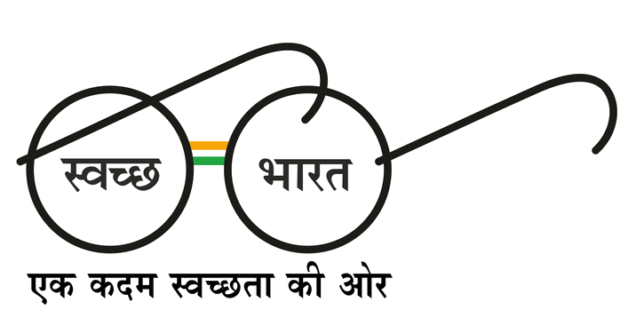
Advertisement No. 15/2018

Seeking Application for Project Internship/Post-graduate Training Programme/ Project Work/ Dissertation Work: for Six Months at NIAB
The Institute provides opportunities for outstanding students to carry out project work under the supervision of the Institute’s scientists towards partial fulfilment of their undergraduate/postgraduate degrees (of at least SIX months’ duration; Session II: July -December). Following procedure should be followed by interested students.
Students who are pursuing undergraduate/master degree (e.g. B. Tech, MSc, MVSc, MTech, integrated master students, etc. in their final year) may apply.
The request must come from the Head of Department, and must provide the academic resumes of the recommended student(s) clearly specifying percentage marks obtained at various levels and the subjects covered, as well as the period of proposed project work. Candidate will be selected based on his/her expertise and the need of NIAB research. The committee decision will be final and not subject to any legal issues.
Applicants must mention their broad area of interest in the application form but distribution of Lab will be based on requirement of individual PIs.
Applications for July-December Session will be accepted from 1st April to 30th April.
Only selected students will be informed by 15th May for July-December Session. Late applications will not be considered.

Applications can be sent to the following email address: admin@niab.org.in. The subject line should mention ‘Six month Trainee application for July-December Session’. This must be followed by a hard copy of application sent to: Senior Manager, ​National Institute of Animal Biotechnology (NIAB), Servey No. 37, Opp. Journalist Colony, Near Gowlidoddi, Extended Q City Road, Gachibowli, Hyderabad, Telangana, India, PIN: 500 032.
Interested applicants may apply, STRICTLY IN THE PRESCRIBED FORMAT mentioned below.
The Institute will not provide any accommodation at the campus. The trainee may make his/her own arrangements for lodging, boarding and travel during the period of the work.
There are no fixed numbers available each year but requests are considered on the basis of available vacancies.

NATIONAL INSTITUTE OF ANIMAL BIOTECHNOLOGY

APPLICATION FORM FOR PROJECT INTERNSHIP
Project Internship/Post-graduate Training Programme/ Project Work/ Dissertation Work: for Six Months
1. Name of Applicant ___________________________________
2. Father's Name ___________________________________
3. Permanent Address ___________________________________
___________________________________
___________________________________
4. Address for Communication ___________________________________
___________________________________
___________________________________
E-Mail ___________________________________
Mobile Phone No. (1) ________________Alternate Mobile No._________
5. Pursuing Degree
(Indicate Department & Courses)_________________________________________
6. Year of study ___________________________________
7. College/Institute/ University
& Place __________________________________
If College/Institute affiliated __________________________________
8. Date of Birth : ........../........../.............
9. Academic Qualifications:
List serially the academic records of all examinations from 10th( Secondary) onwards.
Examination | Name of School/Board/University | Year | Subject | Percentage of Marks* | Division Class
*Marks obtained in grade point, if any, is required to be calculated in terms of percentage. Do not attach copies of the mark sheets. Verification of marks will be done at the time of joining.

Achievement (if any) State-level Medals, Scholarships, Prizes or any Award, Distinction of Honour won:
__________________________________________________________________________________
__________________________________________________________________________________
__________________________________________________________________________________

10. Other Qualification (if Any): ________________________________________
________________________________________________________________________________
11. Research Training (if any): ________________________________________
________________________________________________________________________________

12. Area of Interest/ Broad Subject Area: _________________________________________

13. Name of PI if Communicated before Applying: ____________________________________

Date: -----------------------------------------------------
Place: Signature of the Student

_______________________________
Name of the Student
(in capital Letters)

Recommendation of the Principal/ Institute Head/Head of the Department

I recommend Mr./Ms. ____________________________________________________ for doing the Master's Project of six months duration at National Institute of Animal Biotechnology, Hyderabad and will provide official leave of absence for that.

Principal/Institute Head/ HoD
Date: Signature/with Stamp

